Adicionando o Estado (Rota)

.state(**'client.checkout_view_order'**, {  
 **cache**: **false**,  
 **url**: **'/checkout/view_order/:id'**,  
 **templateUrl**: **'templates/client/view-order.html'**,  
 **controller**: **'ClientCheckoutViewOrderCtrl'**})

Criando checkoutViewOrderCtrl.js

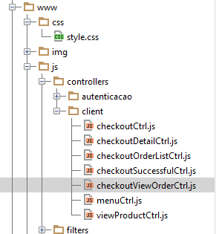.**angular**.module(**'starter.controllers'**).**controller**(**'ClientCheckoutViewOrderCtrl'**,[  
 **'$scope'**, **'$stateParams'**, **'Order'**, **'$ionicLoading'**,  
 **function** ($scope, $stateParams, Order, $ionicLoading) {  
 $scope.**order** = {};  
 $ionicLoading.**show**({  
 **template**: **'Carregando...'** });  
  
 Order.get({**id**: $stateParams.id, **include**:**"items, cupom"**}, **function**(data) {  
 $scope.**order** = data.data;  
 $ionicLoading.**hide**();  
 }, **function**(dataError) {  
 $ionicLoading.**hide**();  
 });  
 }]);

Criar Template view-order.html

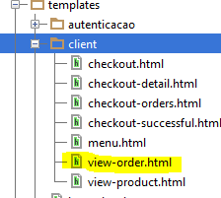

<**ion-view**>  
 <**ion-nav-title**>Pedido: PED#{{order.id}}</**ion-nav-title**>  
 <**div class="bar bar-subheader"**>  
 <**h2 class="title"**>Total: $ {{order.total}}</**h2**>  
 </**div**>  
 <**ion-content class="padding has-subheader"**>  
 <**div class="item item-divider"**>  
 Data da compra: {{ order.created_at.date|limitTo:10|date:'dd/MM/yyyy'}}  
 </**div**>  
 <**ion-list**>  
 <**ion-item ng-repeat="item in order.items.data"**>  
 <**h2**>{{item.product.data.name}}</**h2**>  
 <**div class="row"**>  
 <**div class="col"**>  
 Qtd: {{item.qtd}}<**br** />  
 <**i class="ion ion-cash"**> {{item.price}}</**i**>  
 </**div**>  
 <**div class="col text-right"**>  
 <**i class="ion ion-social-usd"**> {{item.qtd * item.price}}</**i**>  
 </**div**>  
 </**div**>  
 <**span class="item-note"**>  
  
 </**span**>  
 </**ion-item**>  
 </**ion-list**>  
 </**ion-content**>  
</**ion-view**>

Chamar Controller na Index

<**script src="js/controllers/client/checkoutViewOrderCtrl.js"**></**script**>

Adicionar Link no Controller ClientCheckoutOrderListCtrl e na View Orders

$scope.openOrderDetail = **function**(order){  
 $state.go(**'client.checkout_view_order'**, {**id**: order.id});  
};

<**ion-item ng-repeat="o in orders" ng-click="openOrderDetail(o)"** >